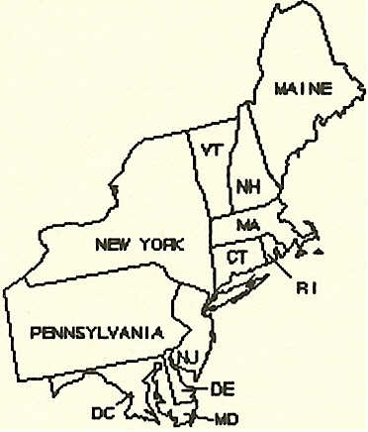
Region II International Christian Education Association
ANNUAL CONVENTION
2019 Pre-Registration
REGISTRATION TEAM
Evangelist Doretha Moody Lady Brenda J. Robinson
________________________________________________________________________________________________________________

REGION II ONLINE REGISTRATION

This year Region II Pre-Registration and On-site Registration can be entered online.

Pre-Registration - Deadline: August 31, 2019
There will be a Registration Link – “Region II Registration” (for individuals to register online) and also a “Region2 Church Report 2019” sent to all churches for entering online registration via computer. This link will be in the form of an Excel spread sheet where you will be required to enter information in seven columns for Pre-Registration.
- Pastor
- District Council
- Church Name
- Title / Salutation
- First name (capitalize first letter of the name only and remainder in lower case)
- Last name (capitalize first letter of the last name only and remainder in lower case)
- Registrants category (Adult, Young Adult, Teen Ages 12-18, Children Ages 4-11)
- Amount (Adults-$16, Young Adults $16, Teens $5 and Children $3)
- After the deadline the Adult and Young Adult fees are $18

Email spread sheet to Evangelist Doretha Moody at dmoody55@yahoo.com
Mail Check to:
Missionary Winnie Jones
C/O Region 2 Registration
P. O. Box 548
Cedar Knolls, NJ 07927-0548

Please do not send cash, make checks payable to ICEA Region II

If you have any questions or concerns, contact:
Evangelist Doretha Moody – dmoody55@yahoo.com cell: 908-930-2171 or
Lady Brenda J. Robinson - ladybjr@hotmail.com cell: 267-679-4429.

Sincerely,

Region 2 – Registration Team

